Implementing Reusable Components & Logic
Tyler Daniels
Southern New Hampshire University
CS-560
Professor Palmer
10-18-26

Implementing Reusable Components & Logic
For this activity, I used a reusable product card to keep the All Products page and Shopping Cart page consistent. Both pages display the product name, price, description, and category-specific details through the same component. This approach reduced repeated code and made the application easier to maintain. If I need to change how prices or product information appear, I can update the shared component instead of editing both pages separately.
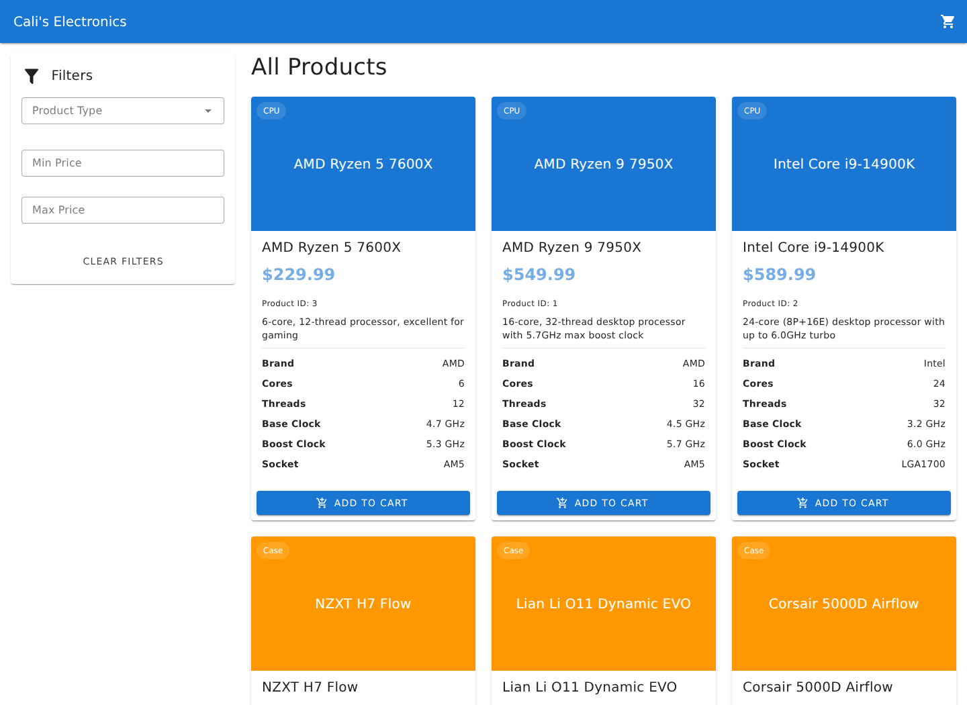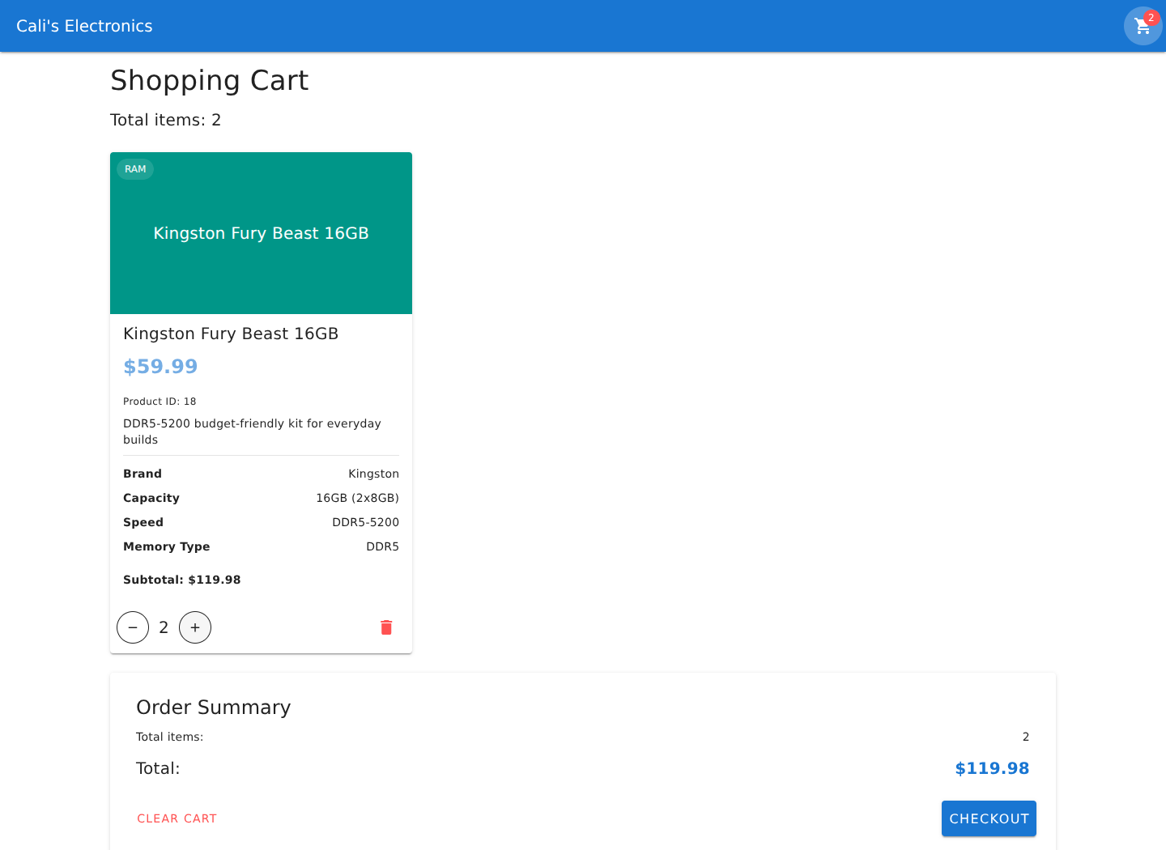
The product card supports flexibility through properties that control which buttons appear. On the All Products page, the card displays an Add to Cart button. In the shopping cart, it displays quantity controls and a remove button. The component also reads each product’s specifications, allowing it to display details for different categories without requiring a separate card for each one. For example, a RAM product can show its capacity and memory type, while a computer case can show its size and form factor. This structure makes it easier to expand the catalog as long as new products follow the expected data format.
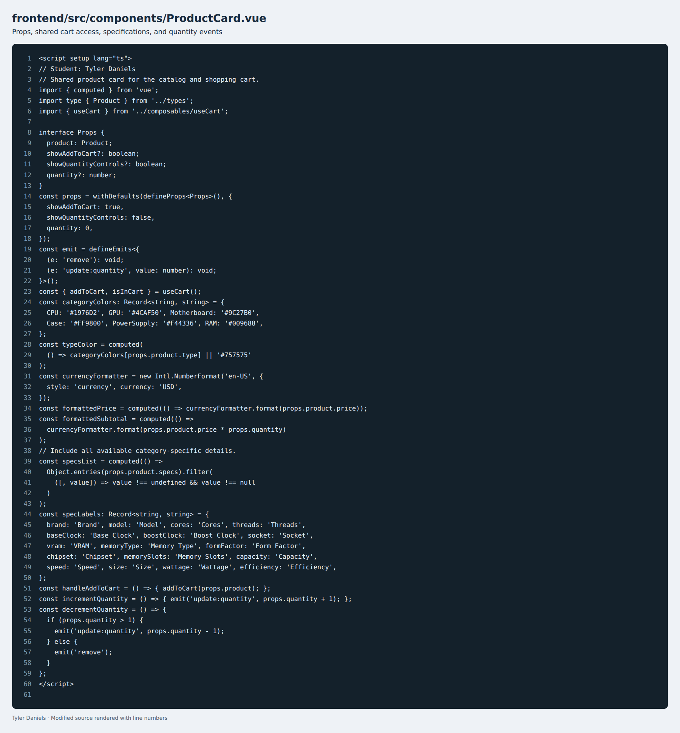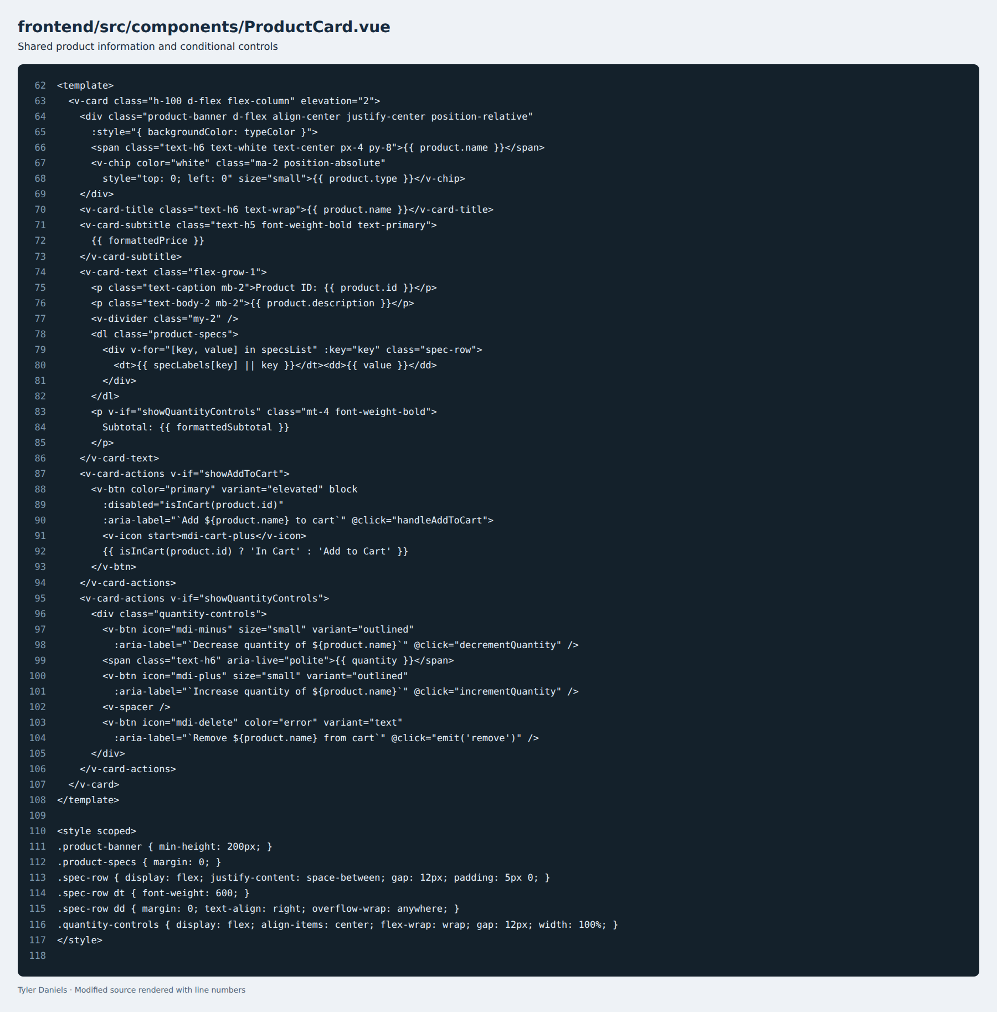
I also reused the shared cart logic so that adding products, changing quantities, and removing items all update the same cart state. The total item count reflects the combined quantities, and the total cost is calculated from each product’s price and quantity. Keeping these calculations together reduces the chance of the cart page and header displaying different totals. It also makes future changes easier because the calculations do not need to be maintained separately in multiple components.
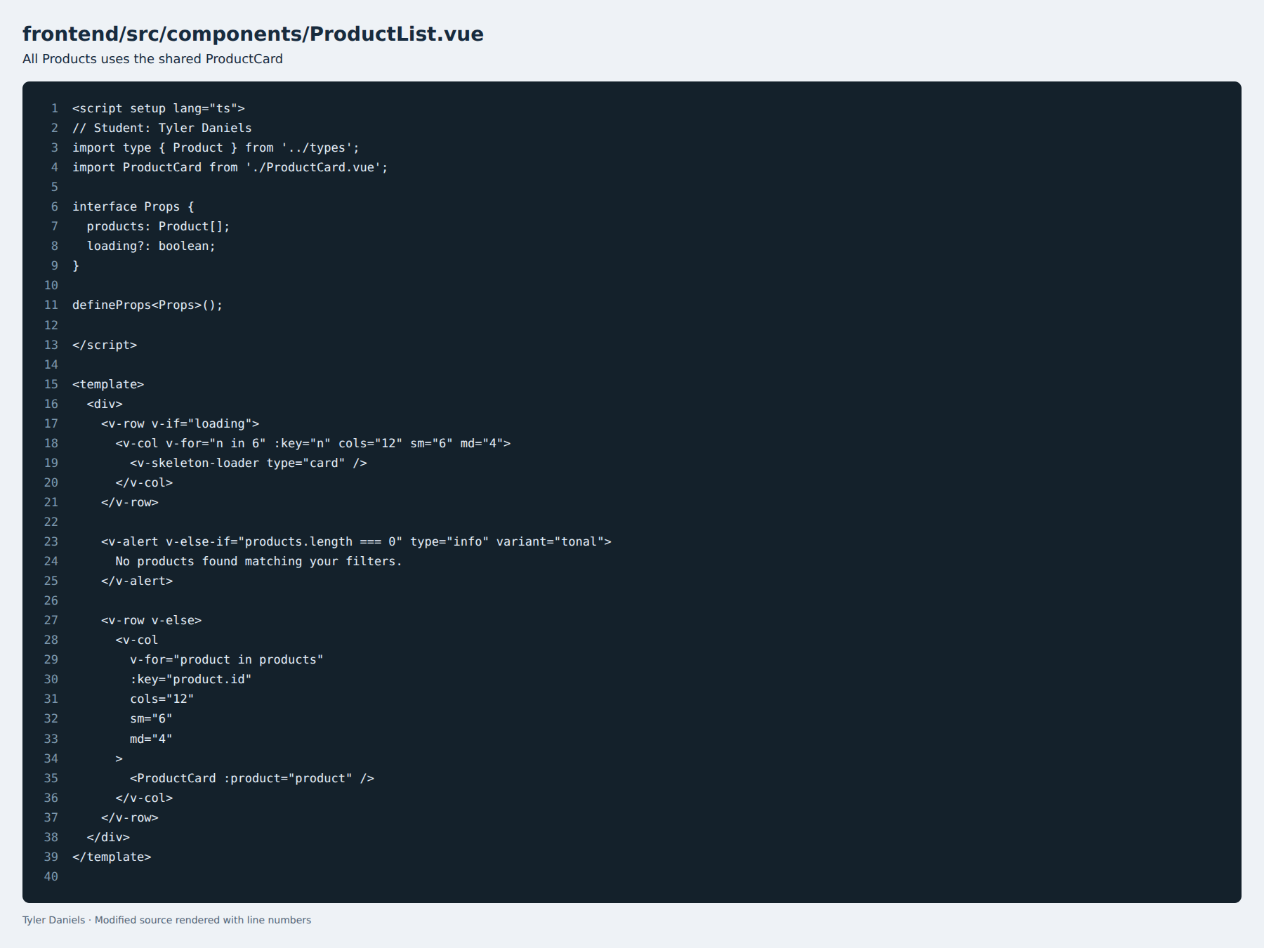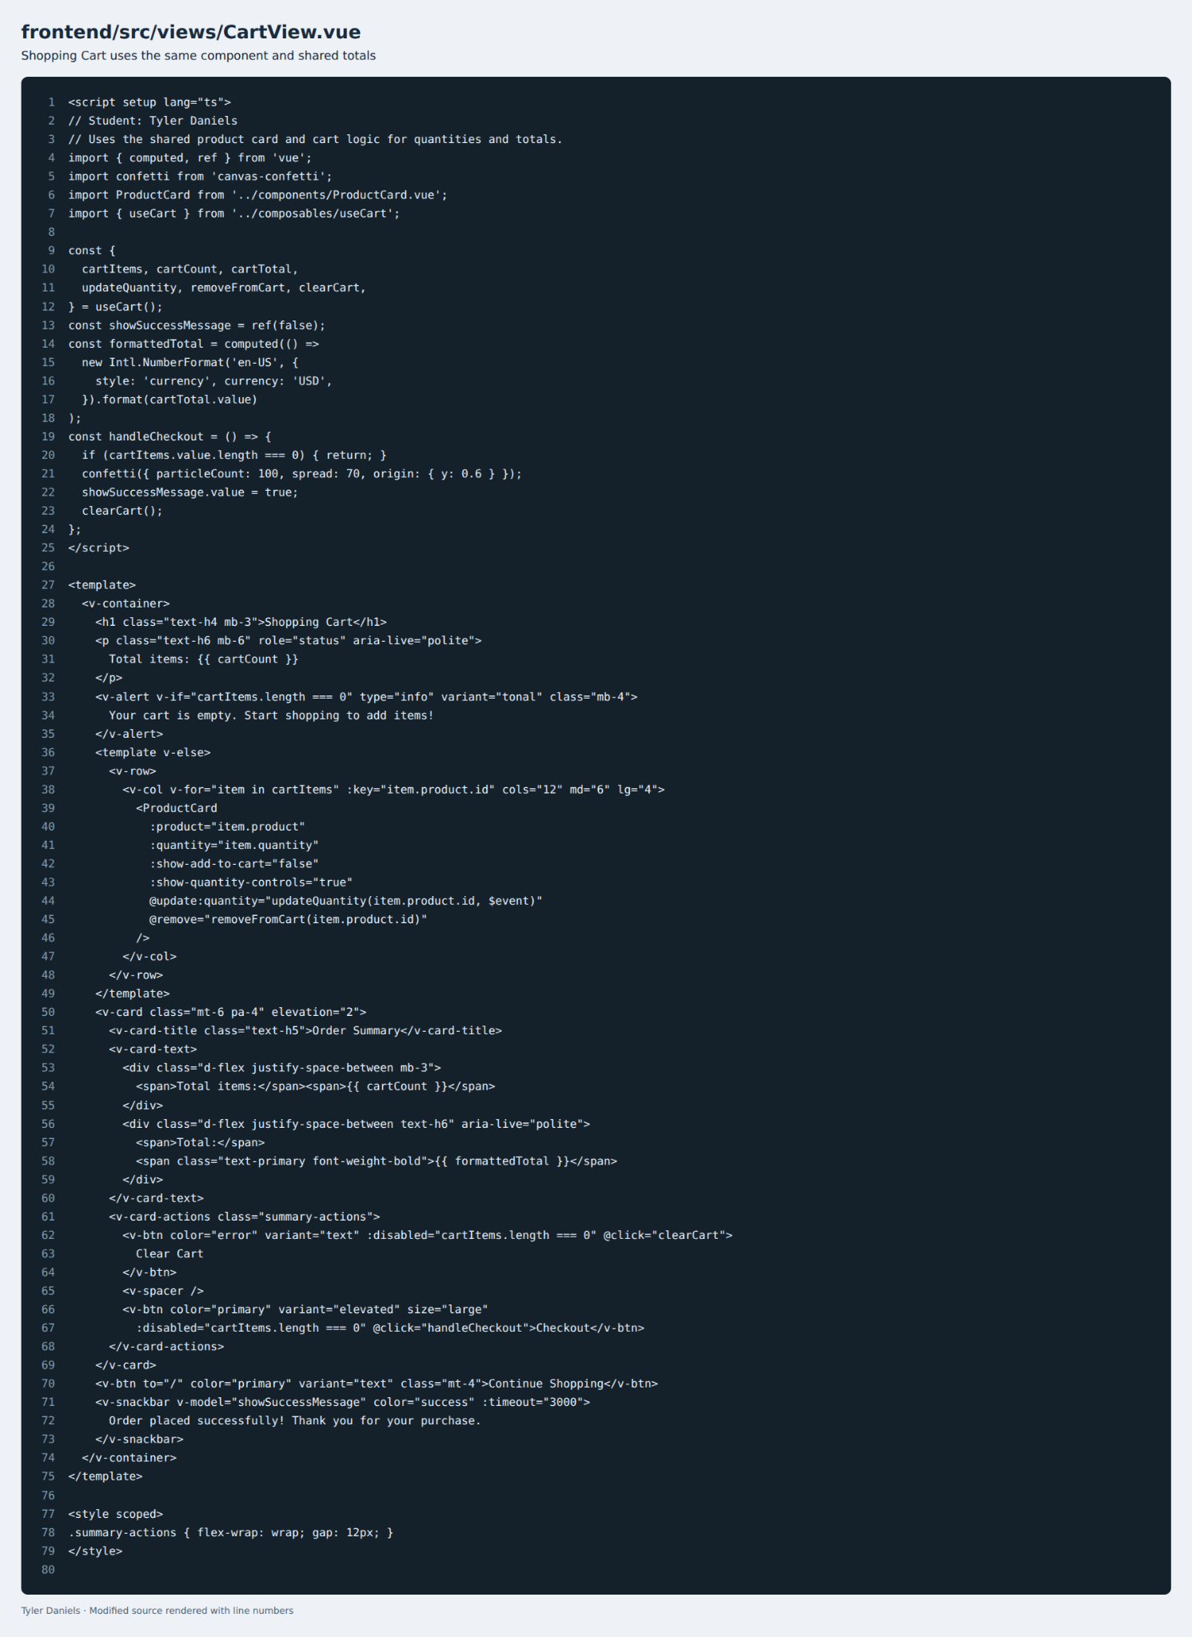
One challenge was making the card work in two different contexts without duplicating its layout. I addressed this by using properties to control the available actions and events to communicate quantity changes and removal requests to the cart page. Another challenge involved getting the development environment working. Missing dependencies and TypeScript configuration errors initially prevented the application from building correctly. Installing the required packages and correcting the configuration allowed me to build and check the application. When the products failed to load, I also needed to make sure the backend was running and available to the frontend.
Testing helped confirm that the shared component behaved correctly in both locations. The Add to Cart comparison shows that selecting the Kingston RAM product places the correct item in the cart at $59.99. Increasing its quantity from one to two updates the item count to two and the total to $119.98. Decreasing the quantity returns the count to one and the total to $59.99. These checks demonstrate that the controls update the underlying cart state and the displayed totals together.
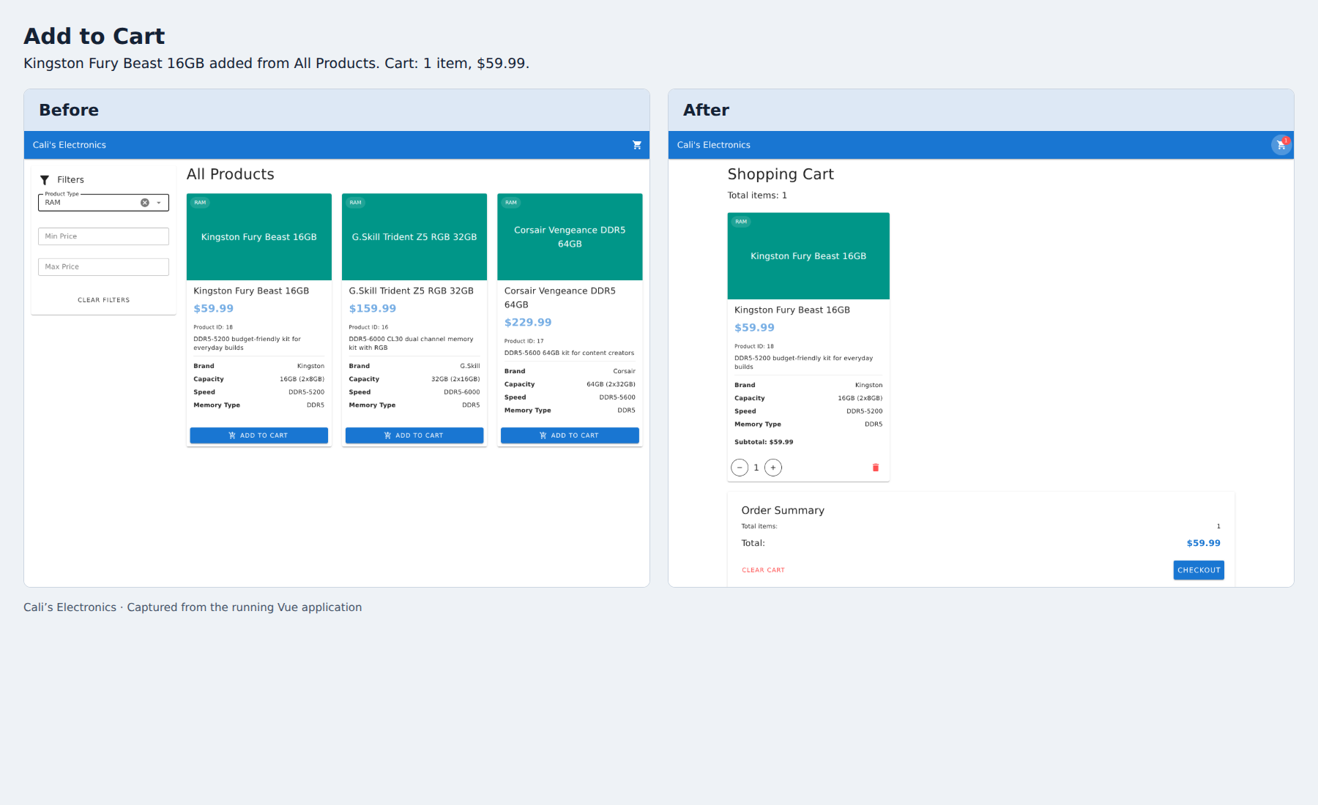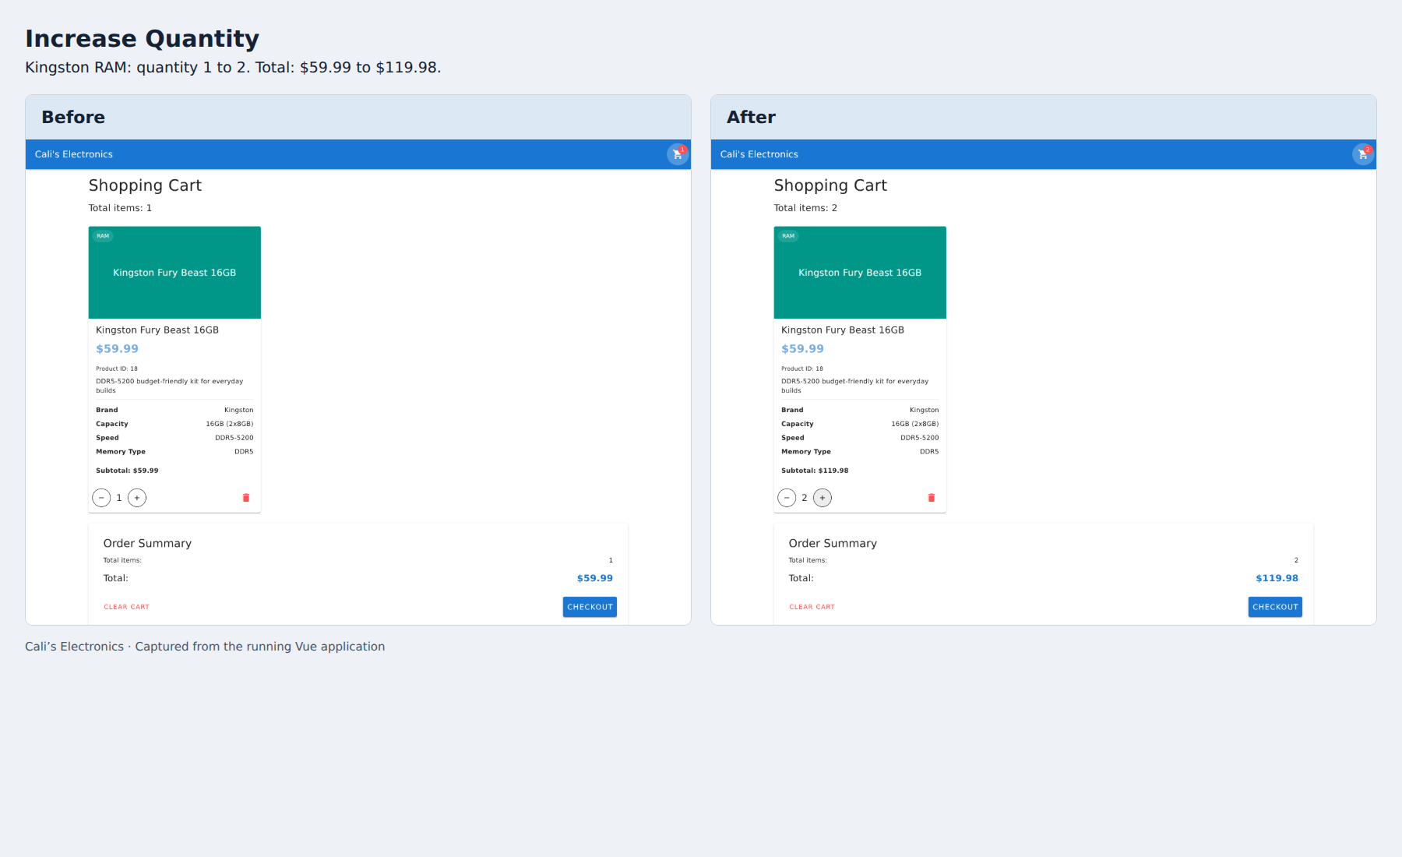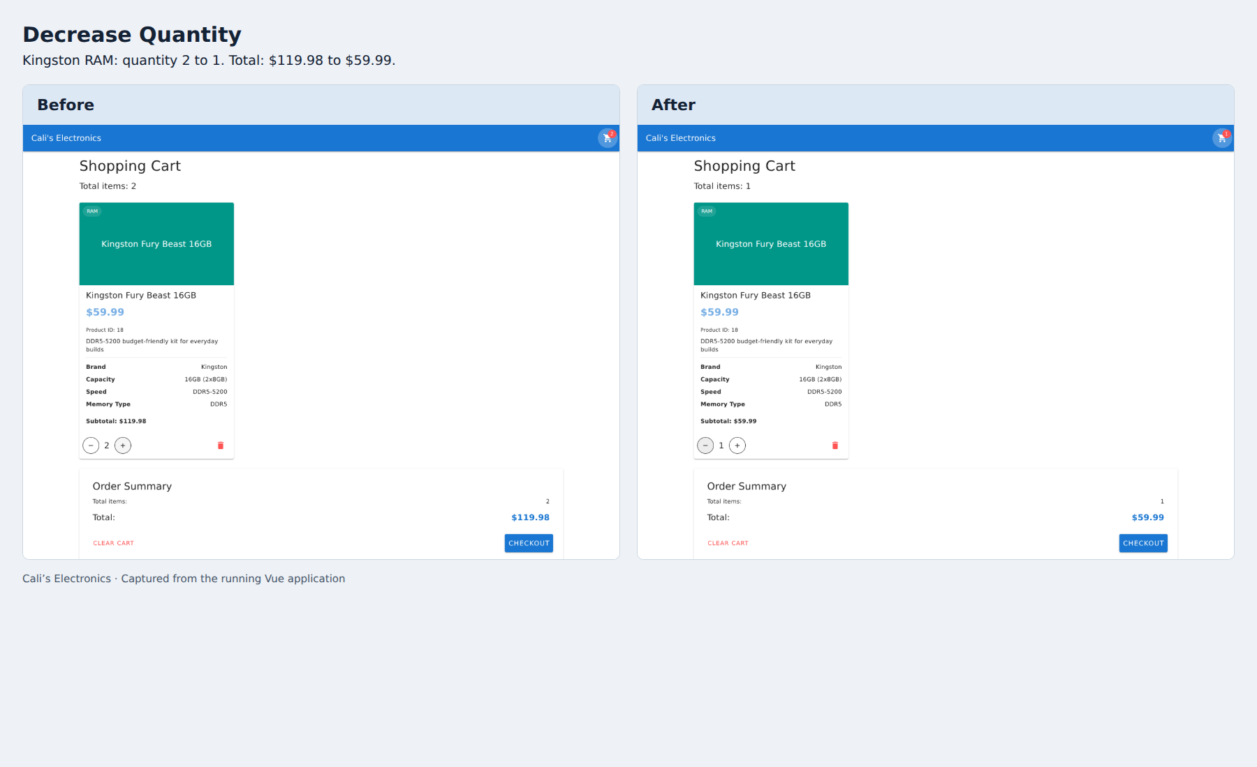
I also checked that removing a product updates the cart without removing the other item. In the removal comparison, deleting the Kingston RAM leaves the NZXT case in the cart. The total item count changes from two to one, and the total cost changes from $189.98 to $129.99. This was an important check because a working remove button needs to update both the visible product list and the order summary.
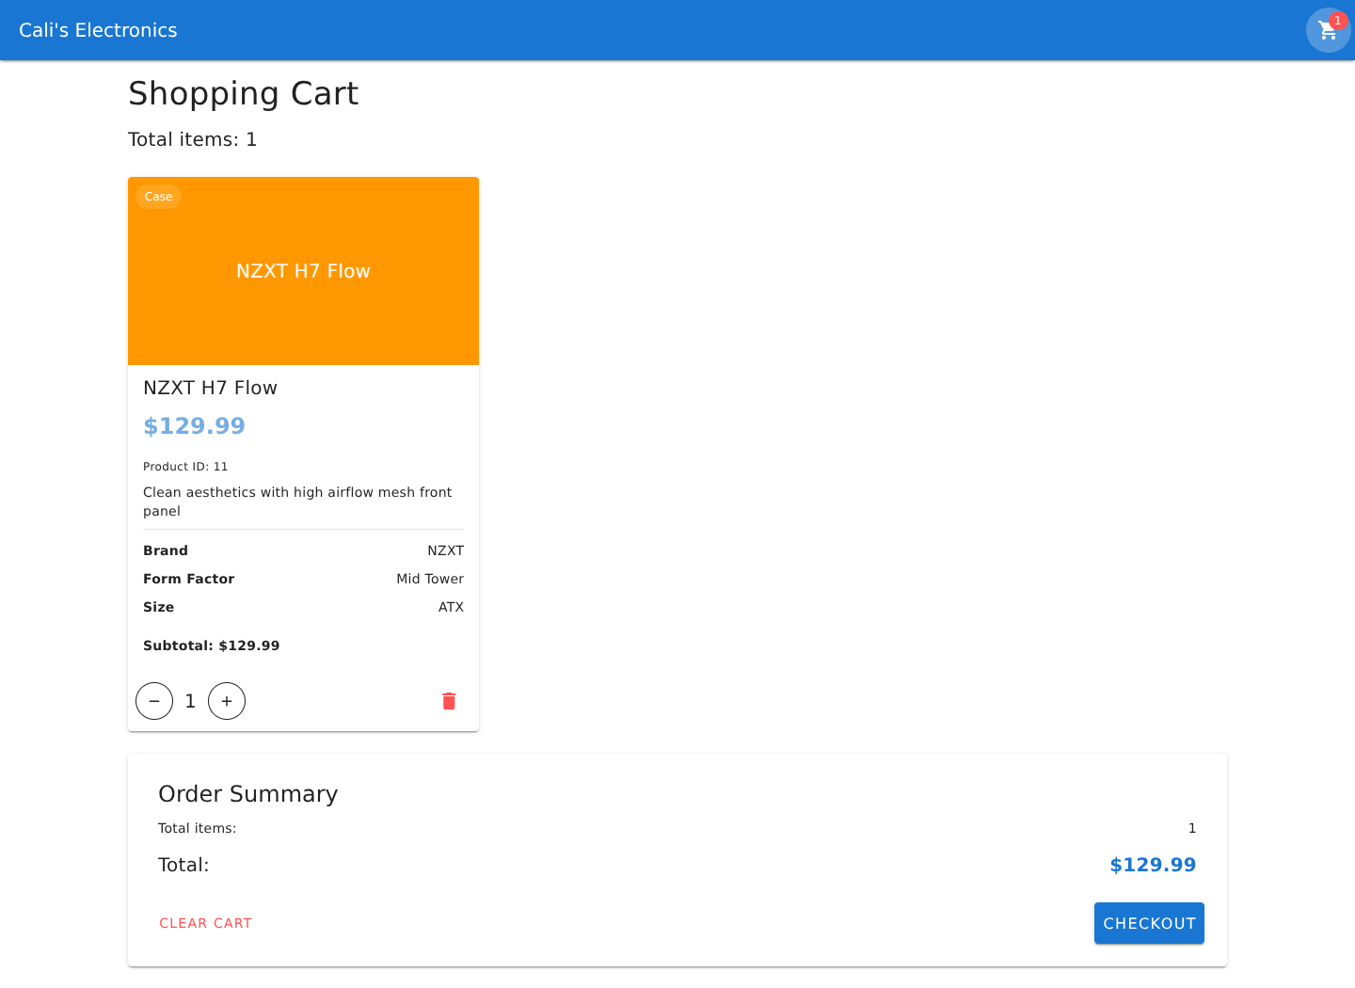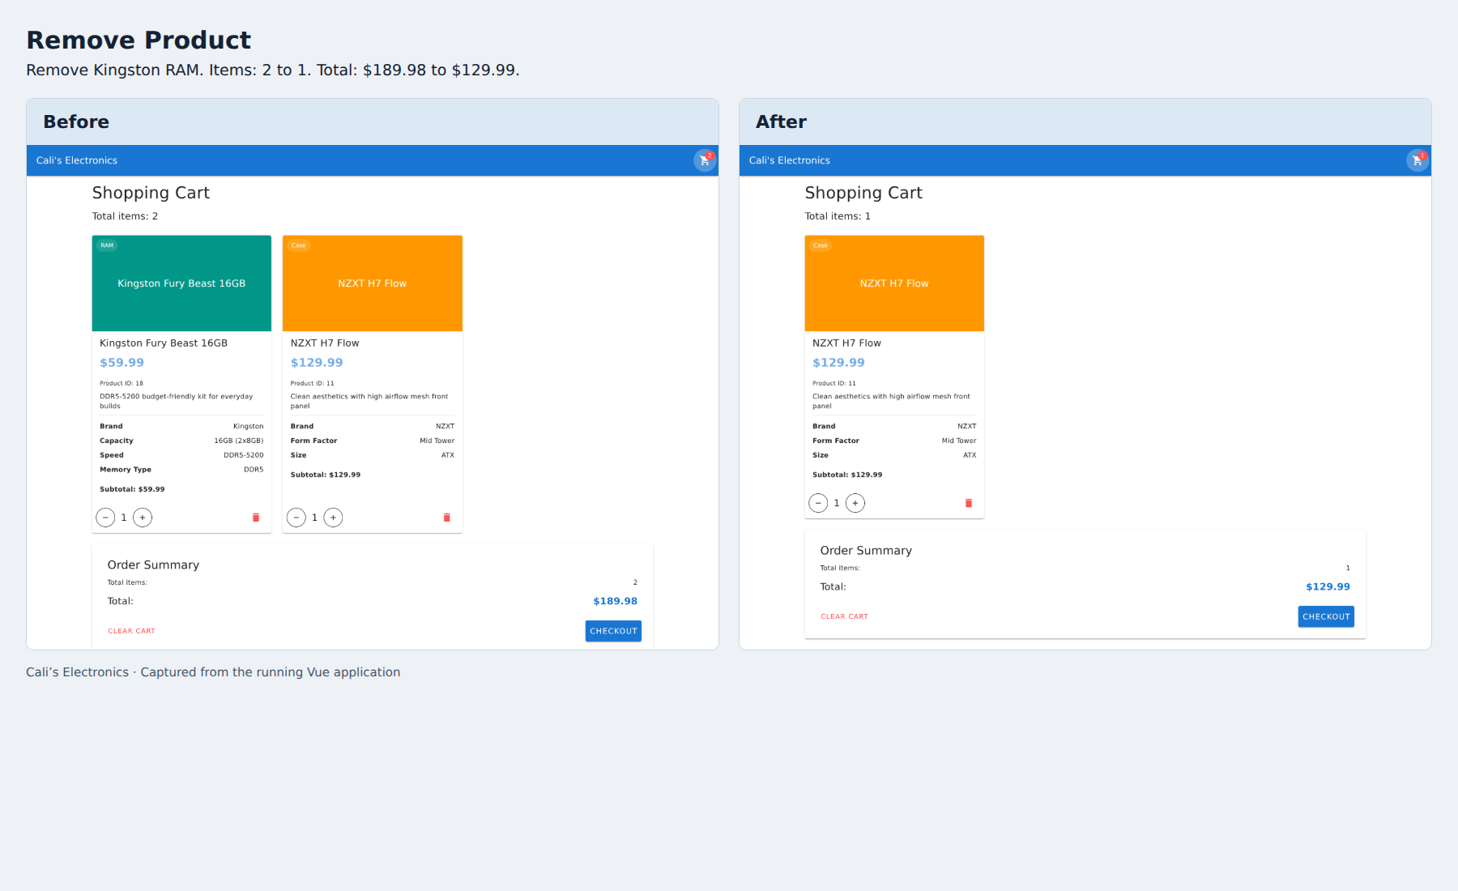
This activity helped me understand how component-based design supports future development. I can apply the same approach to repeated interface elements such as search results, account summaries, or order cards. Building a shared component requires thinking carefully about what stays consistent and what needs to change between screens. In future projects, I would use clear properties, events, and shared logic to keep those responsibilities manageable. That would help me make changes with less repeated work while preserving a consistent experience for users.

